GRMN/LACS 270
Propaganda on the Big Screen

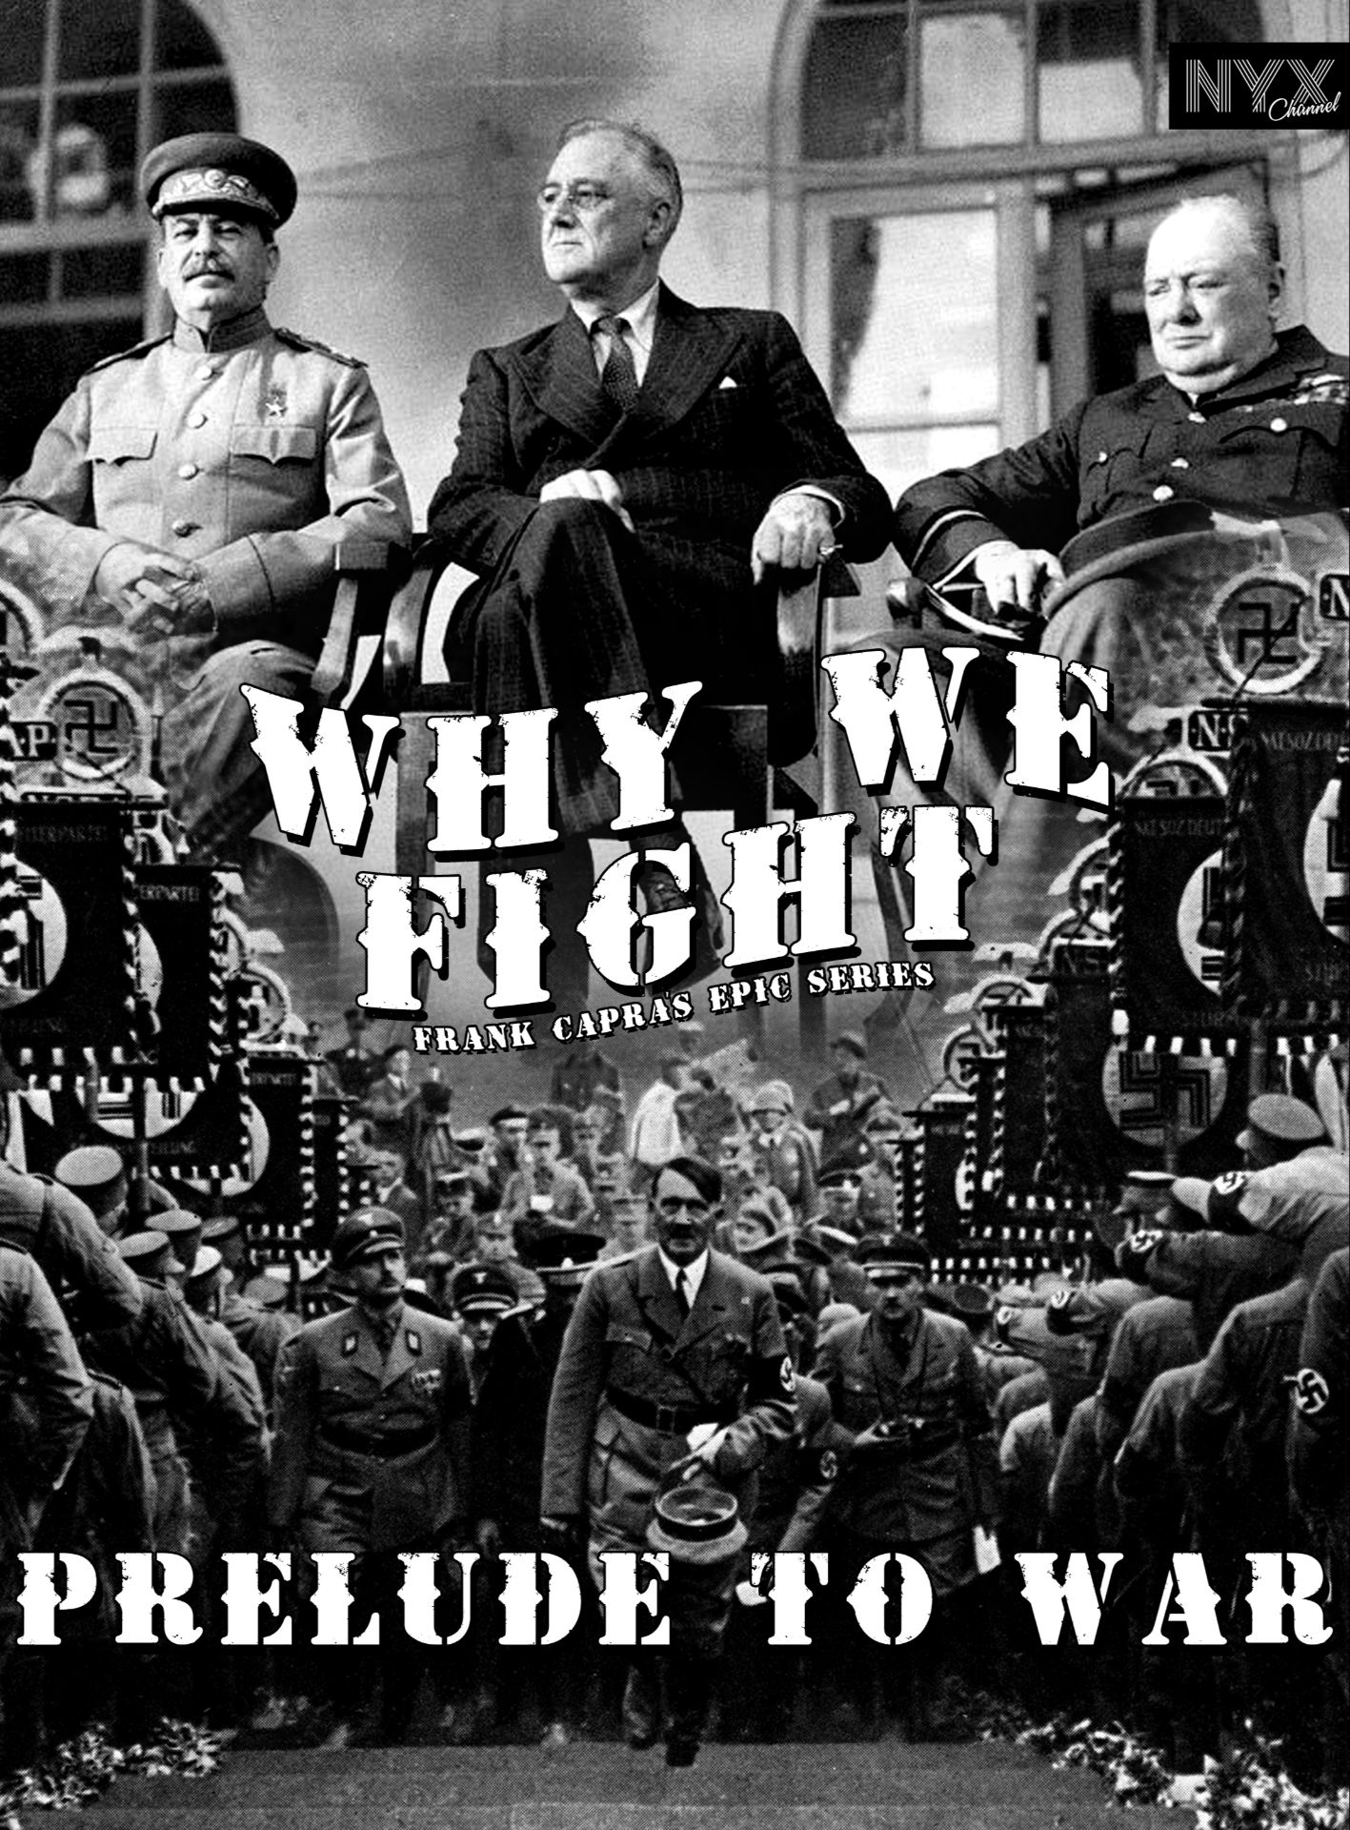

Instructor
Jason Doerre, Ph.D.
Office: Seabury 006 (lower floor)
Office Hours: Wed. 1:30-2:30PM; Thur. 3-4:00PM OR by appointment
Phone: 860 297-2029
Email: jdoerre@trincoll.edu

Course Description
Propaganda has shaped human consciousness since the dawn of civilization. Living in our media-heavy world, we are incessantly bombarded with messaging to such a point that we often take it for granted. Today, propaganda carries a negative connotation because of its association with authoritarian movements of the twentieth century, but propaganda has been equally present in liberal democracy. This course examines the ways in which the medium of film has been instrumentalized for propagandistic purposes since its beginnings to the present. While the theme of propaganda film is too broad to comprehensively cover, this course will consist of a selection of films from the United States, the United Kingdom, France, (East, and Nazi) Germany, the Soviet Union/Russian Federation, and beyond that provide examples of propagandistic messaging. There are no prerequisites to this course, but there is the expectation that all participants dedicate themselves as intellectuals to this seminar. Your work will include (1) engaging with films and readings pertaining to the subject of propaganda; (2) developing a critical perspective on the subject of film and propaganda; (3)applying and adapting ideas in our discussions and written work.

Course Objectives
- Gain a deeper, nuanced understanding of what the term “propaganda” signifies.
- Learn how film has been employed for propagandistic purposes since its inception.
- Identify the impact that film has had to shape consciousness.
- Learn about the ideas, people, places, events of particular moments of the twentieth and twenty-first centuries.
- Understand societies and their use of propaganda film
- Enhance viewing and interpretive capabilities when it comes to the medium of film.

Electronics Policy
Students are permitted to use laptops or tablets in order to access readings and take notes. The use of these devices for any other purpose is not permitted. Should it become apparent that the devices are distracting, they will be banned. Just don’t do it! Under no circumstance should cell phones be used in class, and they should remain out of sight. This is a cell-phone-free zone.

Course Philosophy, Requirements and Grading

As a seminar, this course is based around the fundamental components of the close reading of texts and thoughtful analysis of them in class and in writing. In order to achieve these objectives, you should ALWAYS take care to do the following: 1) carefully read and take notes on all assigned materials, being sure to identify major themes, key passages, new terminology, and formulate questions; 2) participate in class discussion, making reference to the assigned materials and your notes about them and engage with the ideas of your classmates; 3) to prepare for the graded assignments you should rely on the notes that you took while reading/viewing and those you took in class.

A Commitment to Academic Freedom
Higher education is predicated on the exchange, vetting, and deliberation of often controversial and unsettled ideas. In this particular class, for example, we explore propaganda film and its use to shape public opinion in the twentieth century. We are not here to simply express personal opinions or repeat talking points, but rather to engage a set of ideas and research findings that have a long and complicated history and are therefore subject to ongoing debate. Committed students and scholars can, and do, disagree on the topics we will be discussing.
The syllabus has been designed to bring these controversies and disagreements to the fore. Students are also invited to introduce additional challenges in a serious and open-minded manner.
Such conversations require mutual trust and respect. It is therefore essential that students feel free to express their deeply held views and continually developing perspectives. This means ensuring that all students and faculty feel included and welcomed to engage in discussion. Because hateful or discriminatory speech and behavior degrades the possibility for a free exchange of ideas, it will not be tolerated.

Note on Class Climate
Due to the subject of the course, propaganda, the films, readings, and discussions will deal with upsetting and difficult topics including war, unethical practices, sexism, violence, racism, death etc. Emotional responses to the materials may happen, but I expect that we all contribute to the class in a respectful, intellectual, and open fashion. At points in the class, politically sensitive and tense topics may arise. It is expected that all students conduct themselves in a polite and mutually respectable manner, and to respect that some may have differences in opinion. Rude, inappropriate behavior, along with obviously disruptive and inappropriate opinions will not be tolerated.

About the Course Format
Please note that this course is designed as a seminar. I may sometimes include shorter lectures that introduce themes and provide context for the assigned materials. The backbone of the course, however, is class discussion of the materials and topics at hand. The overall collective success of the course, as well as your personal success, depends upon your assiduous attendance, thorough preparedness, and thoughtful contribution in discussing the readings and viewings. No prior knowledge to film studies or twentieth century history is required. However, I do require that everyone rise to the task of conducting herself/himself like an intellectual and be dedicated to learning.

Workload and Expectations
This course will entail viewings and readings that will be done on your time, collaborating with classmates, academic writing, and other preparation. According to the college’s guidelines, you should expect to spend about 9 hours of work outside of class for a one-credit course at Trinity. Please plan accordingly.

Written Analyses
You will write two in-depth analyses. These analyses will be 3–5 pages in length (12pt, double spaced, times new roman, 1’ margins). These papers are analytical exercises in which you provide your original thoughts. They are to be written, printed, and handed to me by the end of class. They will be assessed on the basis of the collective analysis rubric we will be creating in class. Papers not submitted as hardcopy by the end of class will not be accepted, since they will no longer be considered “original.”

Book Review Essay
You will write one critical book review on a book (The Director) that we will read over the course of the semester. In it, you should be able to forcefully explain why or why not this book is an important document about life in a totalitarian system (The Third Reich). Your analysis will be about 3 to 5 pages in length.

Discussion Leads
Every student will take part in 2 discussion leads that will be a portion of the class for that particular day. These designated class periods will have 2 discussion leaders who are responsible for leading the discussion of the reading assigned to a film. These students will be responsible for providing an overview of what the readings for that day are about. Rather than summarize the readings, the students should raise questions, point out problems, make connections, and introduce ideas for the discussion. Because each of you will be a discussion leader in the semester, it is expected that those who are not presenting be attentive and ready to respond. It is suggested that the leaders prepare a PowerPoint presentation that outlines the discussion and has questions. This is NOT a formal presentation but is intended to allow students some agency with the material.

Propaganda Project

The final project will be an exercise of creatively employing what we learned over the course of the semester. You will envision a propaganda film of your own in the context of the eras and turning points that we covered in class. You will have freedom over the form and message of the film. It can be on any topic, idea, ideology, or concept from the context of the course. The point is for you to formulate an idea for a film that has the power to sway how people think about that topic.

There are 3 components to this project:
1.) Towards the end of the semester, you will submit in writing to me what your project will be about.
2.) You will present the film. The presentations can be in any number of forms, including, but not limited to:

- A lecture-style presentation
- Short film
- Pre-recorded radio play
- Speech/monologue
- A skit
- Poster presentation

You have freedom in designing the film idea. Humor, exaggeration, fabrication are not only allowed, but encouraged. The presentations will be about 10 minutes, though there might be some variation depending on the form you choose.

3.) You will submit a written component by the last day of class that will be about 4-6 pages in length and will outline your film idea. The written component should begin with a thesis of what your intentions with the film are and how you plan to achieve it. Other than that, you have considerable freedom here as well.

Despite the freedom in designing, presenting, and completing these projects, I would like to put down a few ground rules:
- No bigotry of any form
- No racism
- No sexism
- No calls for violence per se
- No personal attacks on anyone at Trinity College
- No denigration of any religions
- Everything should be civil and not exceed the rating of PG-13
- Nothing inflammatory

Participation
Regular attendance is required. Being in class is the most essential aspect of a seminar and I will be vigilant in holding students accountable to this. With a second unexcused absence, your participation percentage will be dropped, and for each subsequent unexcused absence. Please refer to the student handbook about excused absences. If your circumstances meet the specifications of an excused absence, you must notify me per email before the beginning of class, or I will deem it as unexcused. Should your absence be excused, you will be responsible for making up for the material you missed that day. If your notification of the absence is too late (i.e., 2 hours before class) your absence will not count as excused. Habitual tardiness will also affect your grade, as too will excessive restroom breaks (leaving class for long periods of time every class period).

Your daily participation will be charted in my gradebook as follows:

√ = in attendance, came prepared, participated OR in the case of an unexcused absence made a satisfactory Moodle post.

— = Came exceptionally late, came insufficiently prepared, or seemed distracted and did not participate

+ = Was in attendance, came prepared, made significant contributions to discussion, thoughtful response

Note: Poor performance will necessarily lower your participation grade. Conversely, I gladly reward high performers.

Grade Breakdown
Participation: 20%
Analyses: 20%
Discussion Leads: 15%
Book Review: 20%
Propaganda Project: 25%

Academic Accommodations
Trinity College is committed to creating an inclusive and accessible learning environment consistent with the Americans with Disabilities Act. Students with disabilities who may need some accommodation in order to fully participate in this class are urged to contact the Student Accessibility Resource Center, as soon as possible, to explore what arrangements need to be made to assure access. If you have approval for academic accommodations, please notify me by the end of week two of classes. For those students with accommodations approved after the start of the semester, a minimum of 10 days’ notice is required. Please be sure to meet with me privately to discuss implementation.
Student Accessibility Resources can be reached by emailing SARC@trincoll.edu.

USE OF AI PROGRAMS
You have certainly heard by now about increasingly popular publicly-available artificial intelligence (A.I.) tools that produce writing when given human input/prompts. There have been many concerns raised by teachers across grade levels and institutions about the prospect of students using such technologies to cheat by having an A.I. write their essays or other writing assignments for them. We will doubtless have ongoing conversations in this course about the role of A.I. writing in our own processes, and even the ways that A.I. can be helpful to us as writers. However, a word of caution: any attempt to pass off A.I. writing as your own in this class constitutes a violation of Trinity College's intellectual honesty policy. As the Student Handbook explains, “Intellectual honesty assumes that students do their own work and that they credit properly those upon whose work and thought they draw” (28-37; 28). Failure to abide by the policy may result in censure, suspension, or even expulsion. The use of A.I. writing tools for the purposes of cheating is also practically unwise for the following reasons:
- - As with any other kind of cheating, the main person you’re cheating is yourself – if you don’t actually put in the work of developing your writing skills organically, you’ve just paid a bunch of money to learn nothing, and that lack of organic skill development will catch up with you eventually.
- - In a word, A.I. writing is not consistently good, and it’s risky to use. A.I. writing software – in its best current iteration – produces writing that is mostly formulaic and generic, lacks the ability to meaningfully integrate critical contextual detail, and cannot properly cite / synthesize sources (in fact, it often fabricates them, which is a major academic integrity violation if caught).
- - For the assignments we will be completing, it is simply much easier to write your own work in this class. A.I. writing tools are notoriously context-blind, and in a class where written work draws on localized concepts and points of discussion from our class (including written reflections on your own personal writing process), you’re likely going to get frustrated if you try to ask an A.I. to perform these tasks for you. I’ve tested the writing prompts & assignments I’ve developed this semester with some of the best A.I. writing tools out there, and none of them can consistently produce writing that meets the standard required for this course.
- - As a human reader and your teacher, I don’t care what you can get an A.I. program to write. I want to hear your unique voice and help you develop it into something you can use and be proud of throughout your life, in a wide array of contexts. So please be genuine in your writing for this class – I promise that will make things far more enjoyable for all of us. (credit to Alex Helberg for this statement)

Course Materials
For your financial wellbeing, most all of the readings will be available on the course’s Moodle page, and the films will be available via Kaltura on Moodle. Please bring all of the readings, as well as your notes about them to each and every class (digital or hard copy).

There is, however, one required text that is available at the Trinity Bookstore:


- Daniel Kehlmann, The Director. 2025.

Please note that some the readings/films are tentative and might change over the course of the semester. All changes will be made on the course Moodle web page.

