Germany and the Great War: Destruction, Myths, and Legacy

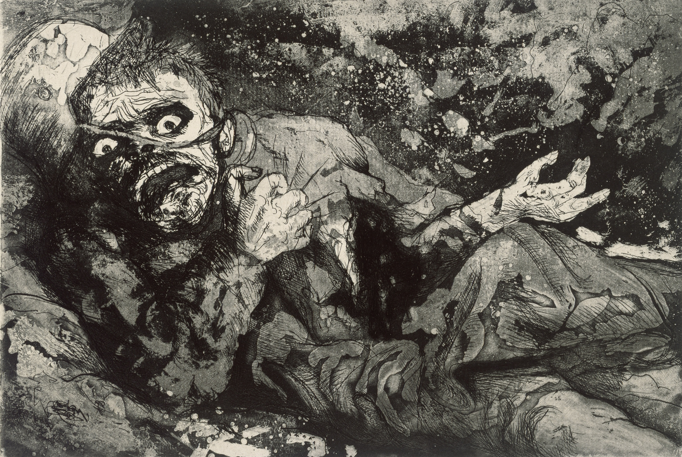

Wounded Soldier, Otto Dix, 1924

Prof. Jason Doerre GRMN/HIST 356
Office: Seabury 009 Spring 2023
Phone: (860) 297-2029 Room: 115V, 103
Email: jason.doerre@trincoll.edu Office Hours: Tue. 2-3; Wed. 4:15-5:15 OR by appt.

The outbreak of World War I marks the end of the long nineteenth century of European history and the beginning of a chaotic twentieth century. For Germany, the war was the culmination of an elongated period that entailed the formation of a national identity, the construction of a nation state, the ascendance of a superpower, and an increasingly jingoistic foreign policy. Germany’s defeat in the war ushered in a period of remarkable social progress, scientific and artistic achievement, as well as unprecedented political instability, which led to the great tragedies of the twentieth century.

This course will examine the immediate causes for the end of Germany’s nineteenth century with its entry into the war to its defeat and the aftermath. With focus on the totality of the experience of this war in German and Austro-Hungarian regions, we will explore important historical works, primary documents, novels, films, works of art and more.

Some Themes to Be Considered:

- Germany in the Long Nineteenth Century
- Europe before WWI
- The Cult of Masculinity and Jingoism
- War Culpability
- War Writing
- Soldier Perspectives
- Civilian Perspectives
- Gender and Minority Perspectives
- The Battles
- The Home Front
- War Weariness and Pacifism
- Versailles and Its Failures
- Modernism and Modernity
- Myths

About the Course Format:

Please note that this course is designed as a seminar. I may sometimes include shorter lectures that introduce themes and provide context for the assigned materials. The backbone of the course, however, is class discussion of the materials and topics at hand. The overall collective success of the course, as well as your personal success, depends upon your assiduous attendance, thorough preparedness, and thoughtful contribution in discussing the readings and viewings. Note that no prior knowledge to German history or World War I is necessary. However, I do require that everyone rise to the task of conducting her/himself like an intellectual, and be dedicated to learning.

The assignments are designed to assess an array of perspectives regarding the experience of World War I. There will be a book review that requires for you to analyze a novel in depth. A midterm exam consisting of short answer questions, and essay question that will be administered in class. The final project will consist of a paper (8-10 pgs.) on a topic of your choosing, approved by me.

Workload and Expectations

This course will entail viewings and readings that will be done on your time, collaborating with classmates, academic writing, and other preparation. There is no prerequisite in terms of prior knowledge about Germany, World War I, European History etc., but it is expected that you are willing to engage with the materials in an intellectual fashion fitting for a college seminar.

According to the college’s guidelines, you should expect to spend about 9 hours of work outside of class for a one-credit course at Trinity. Please plan accordingly.

Final Grade:

Participation 25%
Book Review 15%
Midterm 20%
Discussion Leads 15%
Final Project 25%

Participation:

Your avid participation in each class period is vital to the seminar. Showing up prepared to discuss the materials is the best way to succeed in the class. For each day I will mark participation grades in my notes.

Book Review Essay:

You will write one critical book review on one or more of the three books that we will read over the course of the semester. In it, you should be able to forcefully explain why or why not this book is an important document about the German experience in World War I. Your analysis will be about three to five pages in length.

Midterm:

There will be a written midterm exam that will be administered in class. The midterm will consist of several short answer questions and one longer essay question pertaining to our readings and discussion. The midterm is open notes and you will get a study guide in advance to know the direction of the questions.

Discussion Leads:

Most class periods will have up to two discussion leaders who are responsible for leading the discussion. These students will be responsible for providing an overview of what the readings for that particular day are about. Rather than summarize the readings, the students should raise questions, point out problems, make connections, and introduce ideas for the discussion. Because each of you will be a discussion leader twice in the semester, it is expected that those who are not presenting be attentive and ready to respond. The leaders should prepare a PowerPoint presentation that outlines the discussion and has questions. This is NOT a formal presentation, but is intended to allow students some agency with the material.

Final Paper:

Towards the end of the semester, you will communicate with me about a final paper topic. This paper will be 8-10 pages in length and will be supported by no less than three outside scholarly sources. By the final weeks of classes, you will hand in a paragraph-length abstract that lays out what your paper will be about, as well as a bibliography that tells what sources you will be using.

Note on Use of Electronic Devices:

In the spirit of saving paper and printing costs, I allow you to bring to class an electronic device in order to access the online readings during class, take notes, or even look up terms. Any use of devices during class time other than for class purposes (e.g., reading the PDFs, etc.) is strictly prohibited. Should I see that you are checking emails, surfing the web, or chatting with friends, I will mark your participation grade for that day with a zero. Don’t do it!

Books to Purchase: (Note: all are available at the Trinity Bookstore.

- Ernst Jünger. Storm of Steel. Penguin Classics Deluxe Edition. ISBN: 0142437905. (Available at Trinity Bookstore.)
- Erich Maria Remarque. All Quiet on the Western Front. Mass Market Paperback. Ballantine Books. ISBN: 0449213943. (Available at Trinity Bookstore.)
- Hermann Hesse, Demian: The Story of Emil Sinclair's Youth. Penguin Classics. ISBN: 978-0143106784. (Available at Trinity Bookstore)

Academic Standards
In accordance with the Trinity College Student Integrity Contract, students are expected to abide by the highest standards of intellectual honesty in all academic exercises. Intellectual honesty assumes that students do their own work and that they credit properly those upon whose work and thought they draw. It is the responsibility of each student to make sure that he or she is fully aware of what constitutes intellectually honest work in every examination, quiz, paper, laboratory report, homework assignment, or other academic exercise submitted for evaluation in a course at Trinity College.
Academic Accommodations Statement Trinity College is committed to creating an inclusive and accessible learning environment consistent with the Americans with Disabilities Act. Like many things, the need for disability accommodations and the process for arranging them may be altered by the COVID-19 changes we are experiencing and the safety protocols currently in place.
Students with disabilities who may need some accommodation in order to fully participate in this class are urged to contact the Student Accessibility Resource Center, as soon as possible, to explore what arrangements need to be made to assure access.
If you have approval for academic accommodations, please notify SARC by the end of week two of classes. For those students with accommodations approved after the start of the semester, a minimum of 10 days’ notice is required. Please be sure to email Sheila Njau at sheila.njau@trincoll.edu or SARC@trincoll.edu to schedule a private meeting to discuss implementation.

See Moodle for Course Schedule.

